Project Design Phase
Solution Architecture

Date | 5 October 2026
Team ID | SWTID-2026-4912
Project Name | AI StudyBuddy
Maximum Marks | 4 Marks

Solution Architecture:
The architecture connects the student’s problem (time-consuming study preparation) with a technology solution (a secure, AI-powered REST backend). It defines the structure of the system, its components, and how data flows between them.
Architecture Diagram:
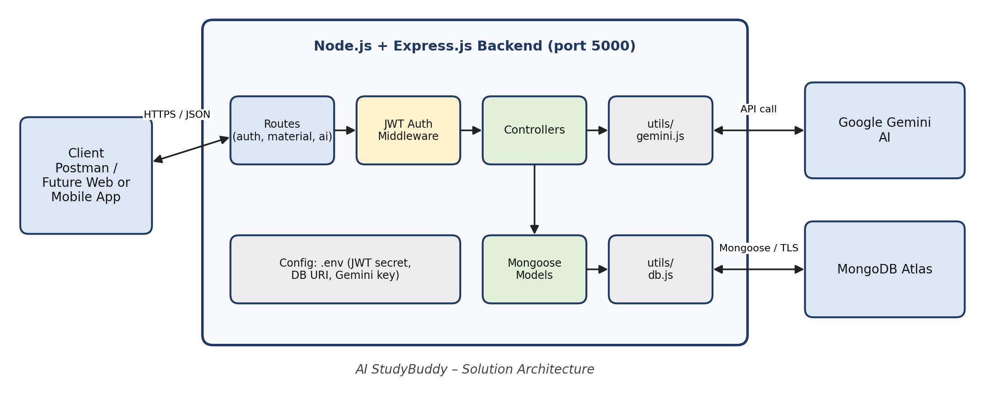
Figure 1: AI StudyBuddy Solution Architecture
Data Flow:
- The client (Postman) sends an HTTPS/JSON request to the Express.js routes.
- The JWT middleware verifies the token on protected routes.
- The controller handles the request and uses Mongoose models to read or write data in MongoDB Atlas.
- For AI features, the controller calls the Gemini utility, which sends a prompt to Google Gemini.
- The generated summary, flashcards, quiz, or study plan is saved and returned to the client as JSON.

